Prose Self Review Sheet
Target I am working on: __________________________________________________
Skill | Self | Teacher
Relevant point
Introduce the quote (set the scene)
Embed the quote
Use the best quote available – relevant and is one you have a lot to say about
Explain the quote in terms of your point and the question
Use keywords from the question throughout
Analyse a technique that has been used
Analyse the language used and discuss the connotations
Interpret the meaning in as many ways as you can – layers of meaning
Use the context as a way of interpreting meaning
Discuss author intention as a way of interpreting meaning
Discuss the effect on the reader
Prove how your point/idea/quote is relevant by returning to the keywords in the question
Keep ideas succinct, don’t repeat yourself or ramble.
Make sure your explanation, analysis and link are relevant to the quote you used.
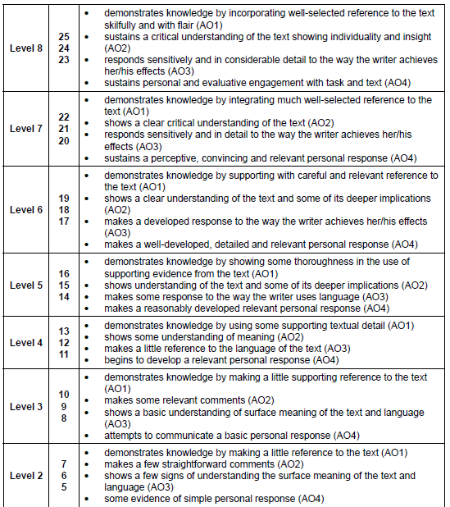
Self-Assessment Mark /25
Teacher mark /25
Targets for improvement:
________________________________________________________________________________________________________________
________________________________________________________________________________________________________________
____________________________________________________________________________________

